SEMINE Integration towards ERP: Xledger
To secure an efficient implementation of SEMINE, please follow the instructions below regarding integration. The implementation project of SEMINE has a tight project schedule and integration is a vital part to achieve success. Please confirm to the project manager in SEMINE when the required setup is done.
 | Technical tasks for Customer | Responsible
1 | Fill in client related information in separate document:  D01.01 – Semine Connect – Template for customer preparations_Xledger.xlsx | Customer
2 | Generate API Token for domain entity with rights as specified below | Customer/ IT Partner
3 | Send the owner entity ID and API Token to Semine project manager | Customer/ IT Partner

Please note that the customer is responsible for the tasks relating to their IT and ERP Partner. The project will not start before the technical tasks are in place.

Entity owner ID:
API Token:

General information
This document describes the settings related to the GraphQL API in Xledger to provide the SEMINE integration with enough access rights to connect to and synchronize data between the two systems.
The organization of the entities in Xledger is assumed to consist of an owner/domain entity with clients as sub-entities below this – so that when providing access to the owner entity all clients are included within the same access scope.
It is possible to set up several integrations if the Xledger installation consists of several different owner/domain entities.
The integration uses GraphQL queries to extract data such as suppliers, dimensions, and accounts and import these to SEMINE so an API token needs to be provided before the integration can be configured.

Generate and provide API Token for owner entity

Since the token generated is tied to the user that generates it, we recommend creating, or use an existing, system or service user for this purpose.
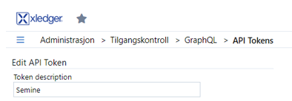
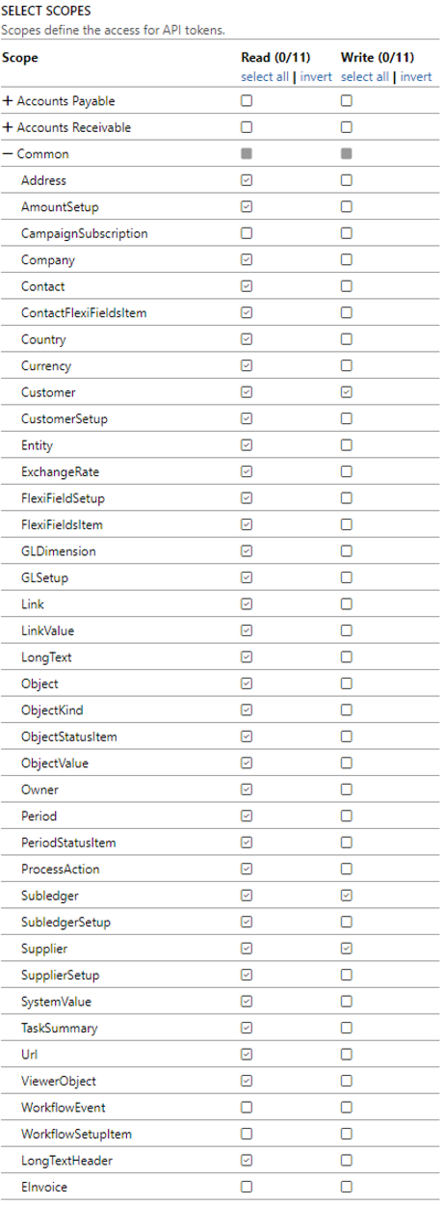
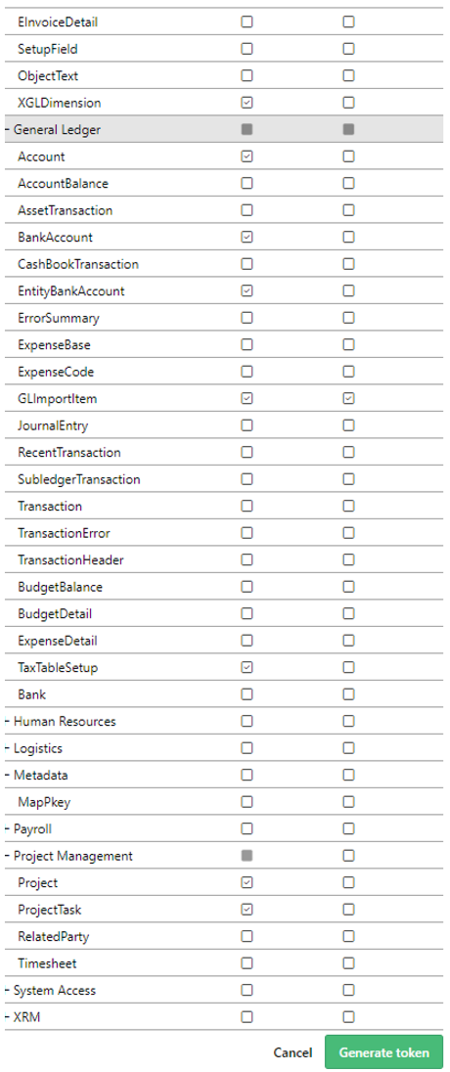

Xledger owner entity ID

In Xledger, Navigate to Administration --> Entity and copy the value of the desired entity’s “Owner ID” field to the table on the first page.
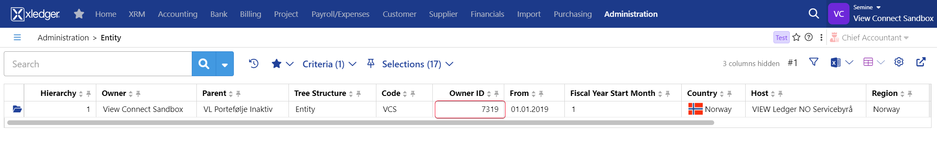

Additional information
The customers' ERP system will be the governing system (Master). Changes are therefore made in the ERP system, which is synchronized to SEMINE at standard intervals. SEMINE sends information to the ERP system every 5 minutes. If other intervals are desired it can be adjusted to fit the requirements, but the project manager in Semine must be notified.
Basic data | Standard setup
Supplier Register | Every 5 minutes
Currencies, Chart of accounts, Financial dimensions | Every 20 minutes
VAT Codes | Every 6 hours
Invoices to Xledger | Every 5 minutes
Fixed Assets | Every hour if applicable

